A
Project Report on

Vishwa Vista Vacations – Travel Online Booking App
Developed at
Sciecore Consultancy Services, Ahmedabad, Gujarat, India
Developed by
Rudrakumar Patel – Department of IT, DDU

Guided By

Internal Guide: | External Guide:
Prof. (Dr.) Harshad B. Prajapati | Mr. Naresh Suthar
Department of Information Technology | Project Manager
Faculty of Technology | Sciecore Consultancy Services
DD University | Ahmedabad, Gujarat


Department of Information Technology Faculty of Technology, Dharmsinh Desai University College Road, Nadiad-387001
April – 2025

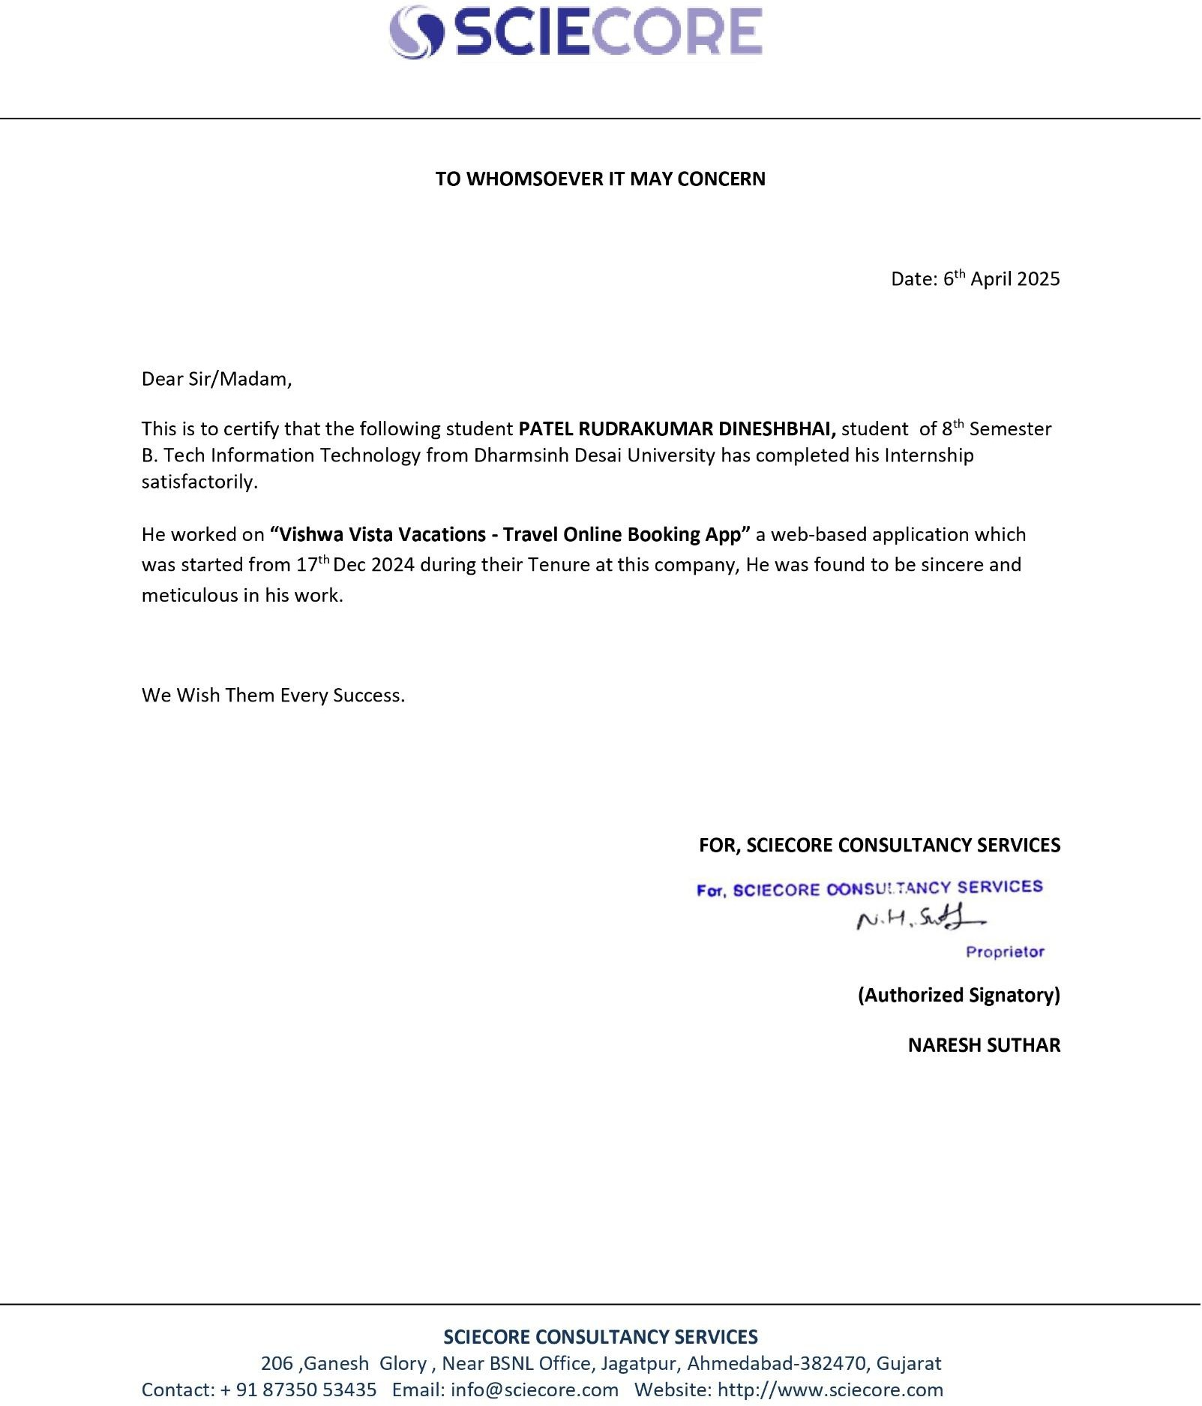
COMPANY CERTIFICATE

I declare that the final semester report entitled “Vishwa Vista Vacations - Travel Online Booking App” is my own work conducted under the supervision of the internal guide Prof. (Dr.) Harshad B. Prajapati and external guide Mr. Naresh Suthar from Sciecore Consultancy Services.

I further declare that to the best of my knowledge the report for B.Tech. final semester does not contain part of the work which has been submitted for the award of B.Tech. Degree either in this or any other university without proper citation.

Candidate’s Signature:
Name: - Rudrakumar Patel
Branch: Information Technology Student ID: 21ITUOS011

DHARMSINH DESAI UNIVERSITY
NADIAD-387001, GUJARAT


CERTIFICATE

This is to certify that the project entitled “Vishwa Vista Vacations - Travel Online Booking App” is a bonafide report of the work carried out by Mr. Rudrakumar Patel Student ID No: 21ITUOS011 of Department of Information Technology, semester VIII, under the guidance and supervision for the award of the degree of Bachelor of Technology at Dharmsinh Desai University, Nadiad (Gujarat). He was involved in Project training during the academic year 2024-2025.

Prof. (Dr.) Harshad B. Prajapati
(Project Guide)
Department of Information Technology, Faculty of Technology,
Dharmsinh Desai University, Nadiad Date:

Prof. (Dr.) Vipul. K. Dabhi
Head, Department of Information Technology, Faculty of Technology,
Dharmsinh Desai University, Nadiad Date:

ACKNOWLEDGMENT
It is truly a pleasure to express my thanks and gratitude to everyone who has helped me throughout the process of making this project. This project gave me a great opportunity to think, implement and interact with different aspects of the software development lifecycle. I would like to thank everyone who has helped us at one time or another by providing me with the support, encouragement, and foundation needed to carry out our project throughout the internship.

I express my deep gratitude to our External Project Faculty, Mr. Naresh Suthar and Internal Project Guide, Prof. (Dr.) Harshad B. Prajapati for their innovative ideas and efforts. Their seriousness to make our project successful. It was their sincerity that inspired us throughout the project to work hard using technologies adopted by the industry.

I am sincerely grateful to Prof. (Dr.) Vipul. K. Dabhi Head of the IT Department, for his unconditional and objective support throughout the research and development process. All of which provide us with a supportive environment.

Without them, I would not have achieved my goal. I thank the manager of Sciecore Consultancy Services for giving me the opportunity to work at.
The combination of gratitude, joy and great satisfaction is what I feel like passing my debt on to all those who have contributed directly or indirectly to the implementation of the project.

With Sincere Regards, Rudrakumar Patel.

Table Contents
ABSTRACT COMPANY PROFILE LIST OF FIGURES LIST OF TABLES

- TRAINING TAKEN IN INDUSTRY 1
  - Objective and Scope of Different Types of Training Undertaken 1
  - Duration and Schedule of Each Training Phase 1
  - Tools and Platform Used 1
  - Week-wise List of Topics covered During Training 1
  - Conclusion and Feedback on Training 4
- INTRODUCTION 5
  - Project Details 5
  - Purpose 5
  - Scope 6
  - Objective 6
  - Technology Review 7
- PROJECT MANAGEMENT 8
  - Product Perspective 8
    - Product Features 8
  - User Classes and Characteristics 8
  - Operating Environment 9
  - Assumption and Dependencies 9
  - Project Development Approach 9
- SYSTEM REQUIREMENTS 13
  - Functional Requirement 13
  - Non-Functional Requirement 14
    - Usability 14
    - Reliability 14
    - Performance 14
    - Security 15
- SYSTEM DESIGN 16
  - Use Case Diagram 16
  - Activity Diagram 17
  - Sequence Diagram 18
  - Class Diagram 19
  - Flow Diagram 20
4.5 ER Diagram 21
- IMPLEMENTATION PLANNING 22
  - Implementation Environment 22
    - Development Environment 22
    - API Development & Testing 22
    - Version Control & Deployment 22
    - Hosting & Deployment 22
    - Security & Authentication 22
    - Third-Party Integrations 22
  - Module Specification 23
  - Coding Standards 23
    - Naming Conventions 23
    - Code Structure & Formatting 23
    - Security Best Practices 23
    - Error Handling & Logging 23
    - API Design Guidelines 24
    - Database Query Standards 24
    - Version Control & Deployment 24
    - Testing & Debugging 24
- TESTING 25
  - Testing Plan 25
  - Testing Strategy 25
  - Test Cases 26
- USER MANUAL 29
- Home Page 29
- Login 30
- Vendor Business Details 30
- Add hotel 31
- Dashboard 31
- Edit Listing 32
- Listing search 32
- Details of Listing. 33
- Payment Gateway 33
- Payment Success 34
- LIMITATION AND FUTURE ENHANCEMENTS 35
  - Limitation 35
  - Future Enhancements 35
  - Vision and applications: 36
  - Summary of project work 36
- CONCLUSION 38
- REFERENCES 40
- EXPERIENCE 41

ABSTRACT
Vishwa Vista Vacations is a travel online booking application designed to simplify the booking process for travellers while providing an efficient management system for vendors. The platform allows users to book hotels, holiday packages, and villas seamlessly, ensuring a smooth and secure experience.

Built with a scalable full-stack architecture, the application uses React.js for the front end and Node.js with Express for the backend, ensuring high performance and responsiveness. MySQL, a relational database, is used for structured data management, optimizing queries for fast and reliable access. Security features include JWT, and mobile OTP authentication (Twilio) to protect user data.

A core feature of the platform is the review and rating system, allowing users to rate their experiences as Excellent, Very Good, Good, or Poor, along with detailed comments. This enhances trust and helps other travellers make informed choices. The app also supports vendor management, enabling property owners to list and manage their accommodations efficiently.

Vishwa Vista Vacations leverages modern technologies to create a secure, scalable, and user- friendly travel booking experience, making travel planning easier and more accessible for everyone.


COMPANY PROFILE
Sciecore Consultancy Services

Sciecore is a leading software development company, providing high-end software solutions to clients across the globe. We innovate and customize development to meet your business requirements.
We offer services to a wide range of industry verticals like Education, Banking, Healthcare, Travel, Real Estate, Insurance, Logistic, Hospitality etc.
We follow transparent work process and keep clients updated. Apart from developing your custom application, we provide best free it consulting Services to grow your business.

Website
- Software Company in Ahmedabad, India | Sciecore
Industry
- IT Services and IT Consulting
Company Size
- 11-50 employees
Headquarters
- Ahmedabad, Gujarat, India.
Type
- Privately Held
Founded
  - 2017

LIST OF FIGURES
Figure 1 Agile Methodology 10
Figure 2 Use_Case Diagram 16
Figure 3 Activity Diagram 17
Figure 4 Sequence Diagram 18
Figure 5 Class Diagram 19
Figure 6 Flow Diagram 20
Figure 7 ER Diagram 21
Figure 8 Home 29
Figure 9 Login 30
Figure 10 Vendor Business Details 30
Figure 11 Add Hotel 31
Figure 12 Dashboard 31
Figure 13 Edit Listing 32
Figure 14 Listing Search 32
Figure 15 Details of Listing 33
Figure 16 Payment Gateway 33
Figure 17 Payment Success 34

LIST OF TABLES
Table 1 Duration of Training 1
Table 2 Week-Wise List of Topics 1
Table 3 Milestones and Deliverables 11
Table 4 Role and Responsibility 12
Table 5 Test Cases 28

TRAINING TAKEN IN INDUSTRY

Objective and Scope of Different Types of Training Undertaken

During my training for the Vishwa Vista Vacations - Travel Online Booking App project, I gained hands-on experience in full-stack development using Node.js, MySQL, Redis, React.js, Tailwind CSS, and GraphQL. The training focused on backend development with Node.js and MySQL for efficient data management, Redis for caching to enhance performance, and GraphQL for optimized data fetching. On the frontend, React.js and Tailwind CSS were used to create a responsive and user-friendly interface. This experience helped me understand scalable application architecture, database optimization, and real-time data handling, preparing me for industry-level development.

Duration and Schedule of Each Training Phase

Training  Undertaken | Duration
Javascript Training | 1 week
React.js & MongoDB, MySQL  Training | 2 weeks
Node.js Training | 2 weeks
Project Work | 7 weeks

Table 1 Duration of Training

Tools and Platform Used

Backend Development: Node.js, Express.js
Database Management: MySQL, Redis (for caching) Frontend Development: React.js, Tailwind CSS
Authentication: JWT, Google OAuth
API Documentation: Swagger (for backend API documentation) Version Control & Collaboration: Git, GitHub
Deployment & Hosting: AWS, Vercel
Development Environment: Visual Studio Code (VS Code), Postman for API testing

Week-wise List of Topics covered During Training

Topics | Duration
- Linux  - Understood  comman  d Linux  - Git commands  - Basics of JavaScript  - Git advance command  revert and  rebase | 1 week

Table 2 Week-Wise List of Topics

React.js & MongoDB,  MySQL Training  - Advance topics of Javascript  - Asynchronous Javascript  - Classes and modules  - Exception  Handling and regex  - REST API  - Error handling  - Basics of React hooks  - Class based components  - Function based components  - React advance hooks  - Code cleaning  - Code refactoring  - State management using context API.  - Basics of Redux  - React  Optimization  - MongoDB Schema | 2  weeks

- Mongoose methods
- MongoDB Atlas
- Query
Optimization
- MySQL(RDBMS)

Node.js Training  - Introduction  - Architecture of Node.js  - Understand of Express server  - Routing  - Middlewares  - Controllers  - App configuration with Options  - Error handling  - REST API controllers  - CRUD operation  - API testing with Postman  - Express Middleware  - Caching  - Session management | 2  weeks
Project Work: Vishwa Vista Vacations – Travel Online Booking App | 7  weeks

Conclusion and Feedback on Training
After finishing this training, I now understand the different technologies and platforms used in our project and how they are applied in real-world situations. I've also learned about software design, working with project management tools, time management, and the importance of group discussions and teamwork.

INTRODUCTION

Project Details

Title: - Vishwa Vista Vacations – Travel Online Booking App Features: -
- Vendor Side
Vendor registration and authentication
Manage hotels, holiday packages, and villas Set pricing, availability, and discounts
Real-time booking management View customer reviews and ratings
- User Side
User registration and authentication
Search and filter hotels, holiday packages, and villas Book accommodations with real-time availability updates Apply discounts and promotional offers
View booking history and manage reservations
- Payment Gateway
Secure online payments with multiple payment options
Integration with popular gateways for seamless transactions Automated invoices and booking confirmations
- Review and Rating
Users can leave reviews and ratings for hotels and packages Review summary with categorized ratings
Vendors can respond to user reviews
- Hotel, Holiday Packages, and Villas
Detailed listings with images, amenities, and descriptions Customizable holiday packages with multiple options
Villa rentals with exclusive offers and personalized services

Purpose

The purpose of Vishwa Vista Vacations – Travel Online Booking App is to provide a seamless, user-friendly, and efficient platform for travelers to search, compare, and book hotels, holiday packages, and villas while enabling vendors to manage their listings, pricing, and availability in real time. By integrating secure payment gateways, a robust review and rating system, and an intuitive booking process, the platform enhances the travel experience for users while offering vendors a scalable solution to expand their reach and optimize their business operations.

Scope

The scope of Vishwa Vista Vacations – Travel Online Booking App includes both user and vendor functionalities, providing a seamless travel booking experience. Users can explore and book hotels, holiday packages, and villas with real-time availability, secure payments, and detailed reviews and ratings. Vendors can manage their listings, update pricing dynamically, and track bookings efficiently. The platform ensures smooth performance with a robust tech stack, including Node.js, MySQL, React.js, Tailwind CSS, and features Swagger API documentation for structured backend integration.

Objective
The objective of Vishwa Vista Vacations – Travel Online Booking App is to create a seamless, efficient, and user-friendly platform that simplifies travel planning and booking. This application is designed to provide a one-stop solution for travelers, offering easy access to flights, hotels, holiday packages, and transportation services.
Key Goals:
- Simplified Booking Process:
  - Develop an intuitive UI that ensures easy navigation for users.
  - Provide a streamlined booking process with step-by-step guidance.
- Real-Time Availability & Dynamic Pricing:
  - Ensure users receive real-time updates on flight seats, hotel rooms, and holiday package availability.
  - Implement a pricing system that adjusts rates based on demand, seasons, and availability.
- Secure Authentication & User Management:
  - Integrate JWT-based authentication, and mobile OTP verification for secure logins.
  - Store user details securely and enable personalized travel preferences.
- Scalable Backend & Database Optimization:
  - Build a high-performance REST API using Node.js and Express.js to handle user requests efficiently.
  - Optimize MySQL queries to ensure fast data retrieval and smooth application performance.
- Secure & Seamless Payment Integration:
  - Support multiple payment gateways like Razorpay and Stripe for smooth transactions.
  - Implement a structured order management system for payments, refunds, and cancellations.
- Advanced Search & Filtering System:

  - Provide search and filtering options based on location, price, travel dates, and user ratings.
  - Allow users to compare different travel options before making a booking.
- Real-Time Notifications & Customer Support:
  - Enable email and push notifications for booking confirmations, updates, and reminders.
  - Provide 24/7 customer support via chat and helpline.
- Multi-Platform Accessibility:
  - Ensure the application is fully responsive and accessible across desktops, tablets, and mobile devices.
  - Develop a progressive web app (PWA) for better mobile performance.

Technology Review

- Frontend: React.js, Vite.js, Tailwind CSS for fast, responsive UI.
- Backend: Node.js, Express.js with JWT, and Twilio OTP for authentication.
- Database: MySQL with Sequelize ORM for optimized queries.
- Payments: Razorpay & Stripe for secure transactions.
- Security & Performance: Bcrypt.js for password hashing, rate limiting, CORS, lazy loading.
A robust, scalable, and secure travel booking platform.

PROJECT MANAGEMENT

Product Perspective

“Vishwa Vista Vacations simplifies travel booking with real-time availability, dynamic pricing, secure authentication, and a seamless user experience.”
Vishwa Vista Vacations – Travel Online Booking App is designed to simplify travel planning by providing users with a seamless booking experience. The platform integrates multiple travel services, including hotel reservations, flight bookings, and tour packages, into a unified system. Built with a scalable backend using Node.js and Express, the app ensures high performance and reliability. The frontend, developed in React.js, offers an intuitive and responsive user interface. Secure authentication is implemented using JWT and Google OAuth to enhance user security. The system optimizes MySQL queries for efficient data retrieval and supports real-time availability updates and dynamic pricing to provide accurate and competitive travel options..

Product Features
User Authentication – Secure login with JWT and Google OAuth
Real-Time Availability – Instant updates on hotel and travel bookings
Dynamic Pricing – Automated price adjustments based on demand Booking Management – Easy reservation, modification, and cancellation Payment Integration – Secure online transactions with multiple options User Dashboard – Personalized trip history and recommendations

User Classes and Characteristics
- Travelers – Users who search, compare, and book flights, hotels, vacation packages, and other travel services. They require an intuitive interface, secure payment options, personalized recommendations, and seamless itinerary management. Features like fare alerts, flexible date searches, and loyalty rewards enhance their experience.
- Vendors – Hotels, airlines, travel agencies, and transport services that list their offerings on the platform. They need an easy-to-use portal for managing inventory, updating pricing, handling customer inquiries, and receiving automated notifications for booking confirmations and cancellations. Integration with their internal systems is also essential.
- Support Team – Customer service representatives who assist travelers with queries, cancellations, modifications, and refunds. They require an efficient ticketing system, AI- powered chat support, escalation handling, and multi-channel communication options (email, chat, phone).
- Corporate Clients – Businesses booking travel for employees in bulk. They need centralized billing, expense tracking, customizable travel policies, and access to corporate deals and negotiated rates

- Developers & IT Team – Ensure platform stability, security, and feature updates. They manage API integrations with third-party services (flights, hotels, payments), optimize database performance, implement new technologies, and address system bugs or vulnerabilities.

Operating Environment

- Platform Compatibility – The application is designed to function on web browsers (Chrome, Firefox, Edge, Safari) and mobile devices (Android and iOS).

- Hosting & Infrastructure – Hosted on a cloud-based infrastructure ensuring scalability, security, and high availability. It integrates with CDNs for fast content delivery and load balancing to handle peak traffic.

- Database & Storage – Uses MySQL for structured data storage, ensuring efficient management of user data, bookings, and transactions. Cloud storage is used for multimedia assets, including hotel images and user documents.

- Security & Compliance – Implements secure authentication using JWT, Google OAuth, and OTP verification. Follows industry standards for data encryption, PCI-DSS compliance for payment security, and GDPR compliance for data privacy.

- Third-Party Integrations – Connects with external APIs for flight, hotel, and transport bookings. Supports payment gateways for transactions via credit/debit cards, UPI, and wallets. Integrates with email and SMS services for notifications.

- Network & Performance – Designed to function efficiently in varying network conditions with optimizations for low-bandwidth environments. Uses caching mechanisms to enhance performance and reduce load times.

- User Accessibility – Ensures responsiveness and usability across different screen sizes, with accessibility features for differently-abled users, including screen reader support and high- contrast modes.

Assumption and Dependencies

The user should have basic knowledge of computers and software. The user should have Internet connectivity.

Project Development Approach

The Agile Model is used for project development. We have selected Agile Model because of its beneficial speed without affecting the quality of product and agile makes the team so much more productive.

Agile Model

Agile SDLC model is a combination of iterative and incremental process models with focus on process adaptability and customer satisfaction by rapid delivery of working software products. Agile Methods break the product into small incremental builds. These builds are provided in iterations. Each iteration typically lasts from about one to three weeks. Every iteration involves cross functional teams working simultaneously on various areas like planning, requirements analysis, design, coding, unit testing, and acceptance testing. At the end of the iteration a working product is displayed to the customer and important stakeholders.

What is Agile?

Agile models believe that every project needs to be handled differently and the existing methods need to be tailored to best suit the project requirements. In agile the tasks are divided into time boxes (small time frames) to deliver specific features for a release.

Iterative approach is taken and working software build is delivered after each iteration. Each build is incremental in terms of features; the final build holds all the features required by the customer.

Advantages of using Agile Model
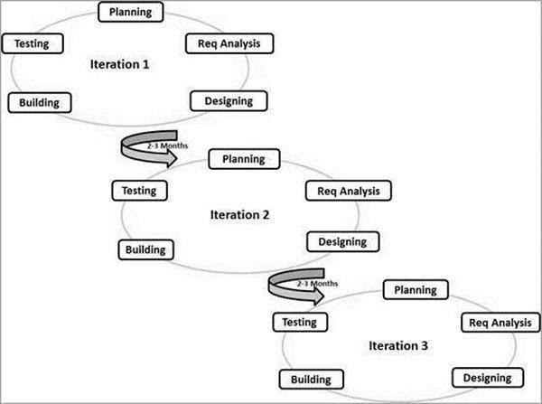
Figure 1 Agile Methodology

Customer satisfaction by rapid, continuous delivery of useful software. People and interactions are emphasized rather than processes and tools. Customers, developers and testers constantly interact with each other. Working software is delivered frequently (weeks rather than months). Face-to-face conversation is the best form of communication. Close, daily cooperation between business people and developers. Continuous attention to technical excellence and good design.

Disadvantages of using Agile Model

In case of some software deliverables, especially the large ones, it is difficult to assess the effort required at the beginning of the software development life cycle.
There is a lack of emphasis on necessary designing and documentation. The project can easily get taken off track if the customer representative is not clear what final outcome that they want.

Only senior programmers are capable of taking the kind of decisions required during the development process. Hence it has no place for newbie programmers, unless combined with experienced employees.

Milestones and Deliverables

Milestones are identified in order to complete the entire project in the time duration. Milestones are identified for every sprint of Crest Data Systems.

PHASE | DELIVERABLES | PURPOSE
System Requirement and Analysis | - Requirement Gathering and analysis.  - Functional Specification  - Non-functional Specification | It gives an exact understanding of the user’s  requirements.
System Design | - Class Diagram  - Use Case diagram  - Sequence diagram  - Activity diagram | It gives the  logical structure that describes the system.
Table 3 Milestones and Deliverables

Implementation & Testing | - The output obtained for the required  functionality after  implementing and doing testing. | It makes the  system robust and reliable.

Roles and Responsibility

Name | Role
 | Anal ysis | Design ing | Cod ing | Test ing | Document ation
Rudraku mar  Patel | ✓ | ✓ | ✓ | ✓ | ✓

Table 4 Role and Responsibility

SYSTEM REQUIREMENTS

This Section describes all Functional as well as Non-functional requirements. It contains descriptions of functions and capabilities that the product must provide.

Functional Requirement
Functional requirements define the features and capabilities of the Vishwa Vista Vacations – Travel Online Booking App and describe how it must behave.

F1: User Authentication
- Input: Email, password, or third-party login (OTP).
- Output: User logged in and redirected to the dashboard.
- Processing: Credentials are verified, and JWT token is generated for session management.

F2: User Registration
- Input: Name, email, phone number, password, etc.
- Output: Successful account creation, redirection to profile setup.
- Processing: User details stored in the database, confirmation email sent.

F3: Search and Compare Travel Options
- Input: Destination, travel dates, number of passengers, and preferences.
- Output: A list of available flights, hotels, and vacation packages.
- Processing: Queries are processed through integrated travel APIs to fetch and compare options.

F4: Booking Management
- Input: Selected flight, hotel, or package details.
- Output: Booking confirmation and e-ticket generation.
- Processing: The system processes the payment, updates availability, and sends booking details via email/SMS.

F5: Payment Processing
- Input: Payment details (credit/debit card, UPI, wallet, etc.).
- Output: Successful transaction and payment receipt.
- Processing: Payment is securely processed using integrated gateways, and confirmation is sent.

F6: Real-Time Availability Updates
- Input: Booking updates from vendors.
- Output: Live status of flight seats, hotel rooms, and package availability.
- Processing: Vendor data is synced in real-time to prevent overbooking.

F7: Dynamic Pricing and Discounts
- Input: User location, demand, seasonal trends, and offers.
- Output: Adjusted pricing based on real-time demand.
- Processing: The pricing engine analyses demand and vendor rates to display dynamic prices.

F8: Booking History and Itinerary Management
- Input: User request to view past bookings.
- Output: Display of all previous and upcoming bookings.
- Processing: Fetch and present user booking details from the database.

F9: Cancellation and Refund Processing
- Input: User request for cancellation with a reason.
- Output: Refund confirmation and processing status.
- Processing: The system verifies cancellation policies and processes refunds as per vendor rules.

F10: Customer Support and Chat Assistance
- Input: User queries via chat or support ticket.
- Output: Real-time assistance or ticket resolution.
- Processing: Queries are directed to live agents or automated chatbots for quick resolution.

Non-Functional Requirement

Usability

The system shall provide a seamless and user-friendly experience for travelers, vendors, and administrators. The interface will be designed to ensure smooth navigation, allowing users to search, compare, and book travel services effortlessly. Features like search filters, sorting options, and interactive maps will enhance usability. The platform will support a responsive design, ensuring accessibility across mobile, tablet, and desktop devices. Minimal training should be required for users to understand and operate the system efficiently.

Reliability

The platform shall maintain high reliability, ensuring that users can access and complete bookings without disruptions. The system will be designed to handle multiple concurrent users and transactions without failures. Real-time updates in availability and pricing will prevent overbooking and discrepancies. Automated data backups and failover mechanisms will be implemented to ensure recovery in case of unexpected failures. The system must function smoothly under varying network conditions and ensure uptime even during peak usage periods.

Performance

The platform shall be optimized for high-speed performance, ensuring quick response times for searches, bookings, and transactions. Search results should be displayed within 2-3

seconds, and booking confirmations must be processed within 5
seconds under normal conditions. The system will utilize efficient database queries and caching mechanisms to enhance speed and reduce load times. The backend infrastructure must be capable of handling high traffic, especially during peak travel seasons, without any slowdown or service interruption.

Security

The system will incorporate strong security measures to protect user data and transactions. Authentication mechanisms such as JWT-based authentication will be implemented to prevent unauthorized access. Sensitive user information, including payment details, will be encrypted using industry-standard encryption protocols. Role-based access control will restrict unauthorized modifications, ensuring that only verified users can perform specific actions. Security measures against phishing, fraud, and cyber threats will be enforced to maintain the integrity of the platform.

SYSTEM DESIGN

Use Case Diagram

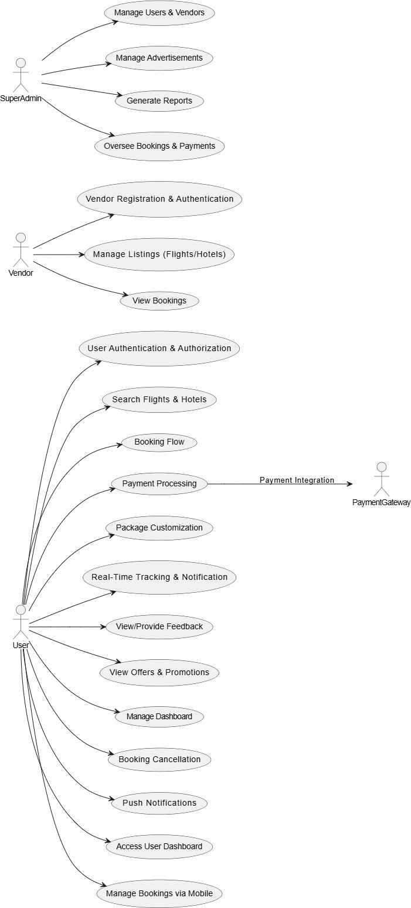
Figure 2 Use_Case Diagram

Activity Diagram

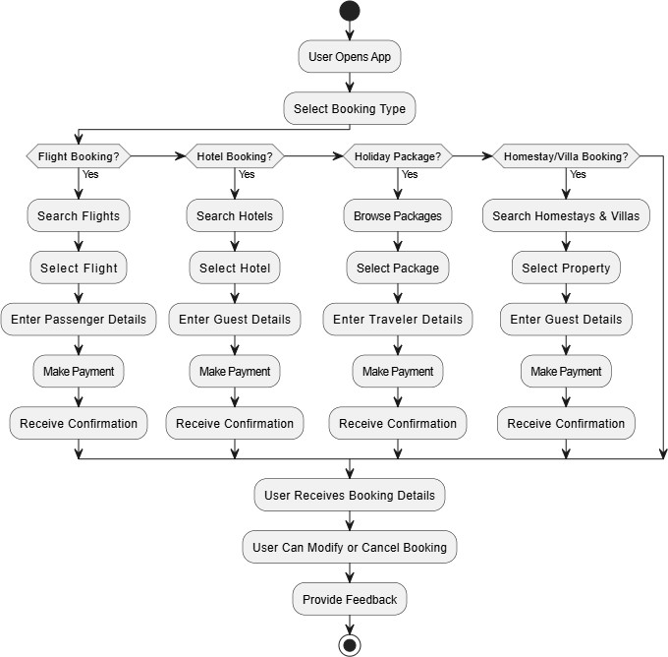
Figure 3 Activity Diagram

Sequence Diagram

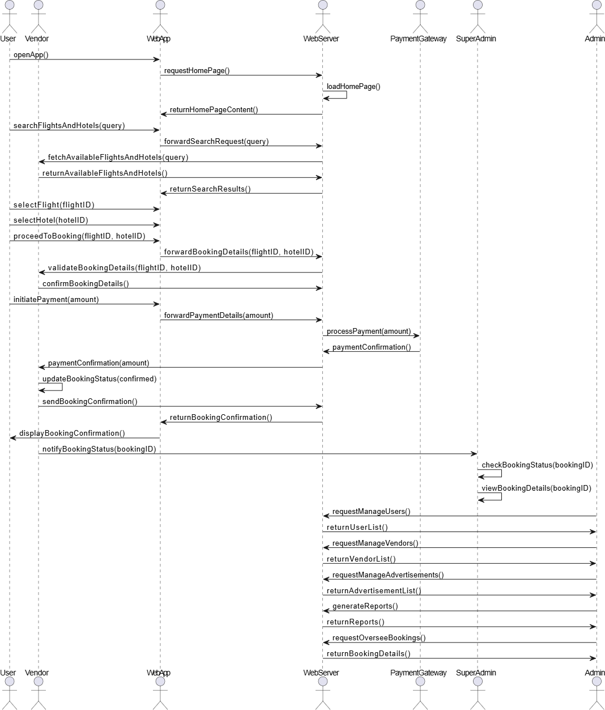
Figure 4 Sequence Diagram

Class Diagram

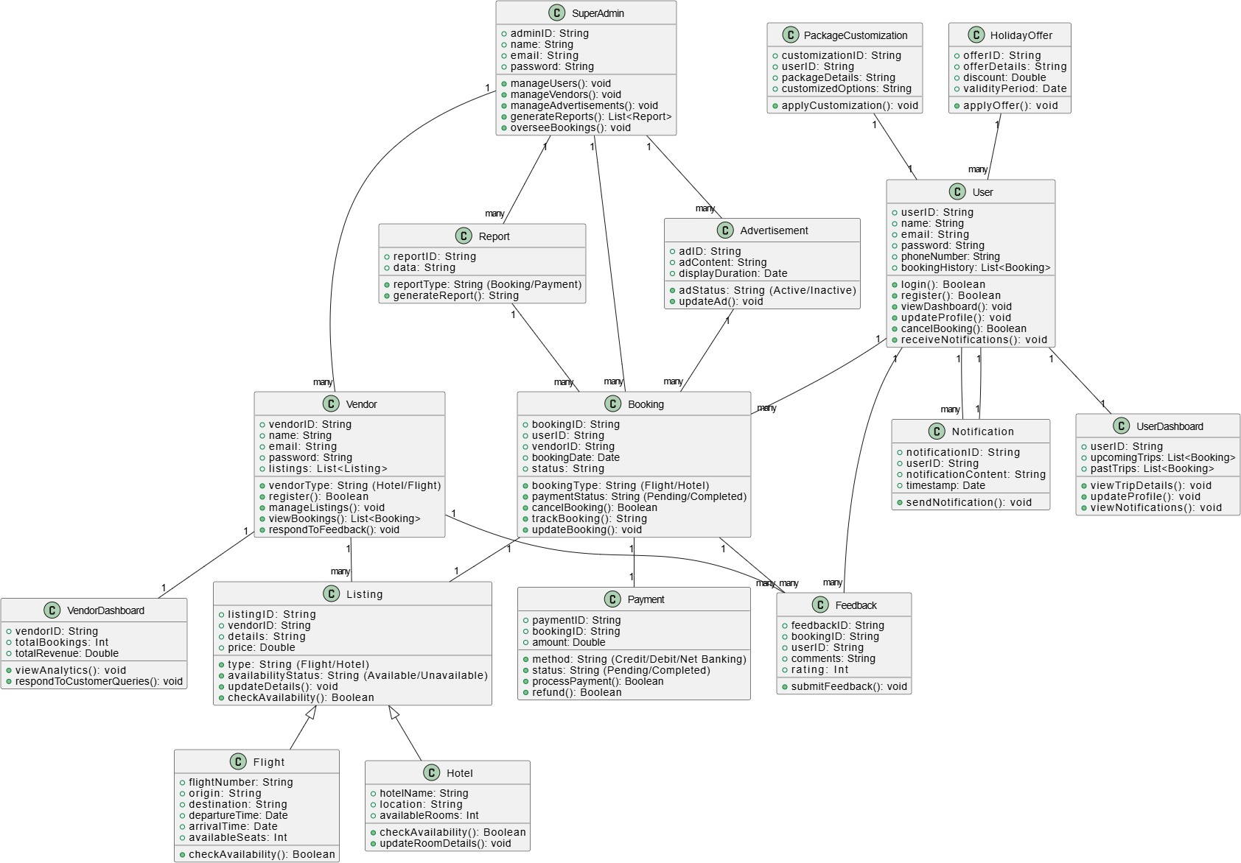
Figure 5 Class Diagram

Flow Diagram

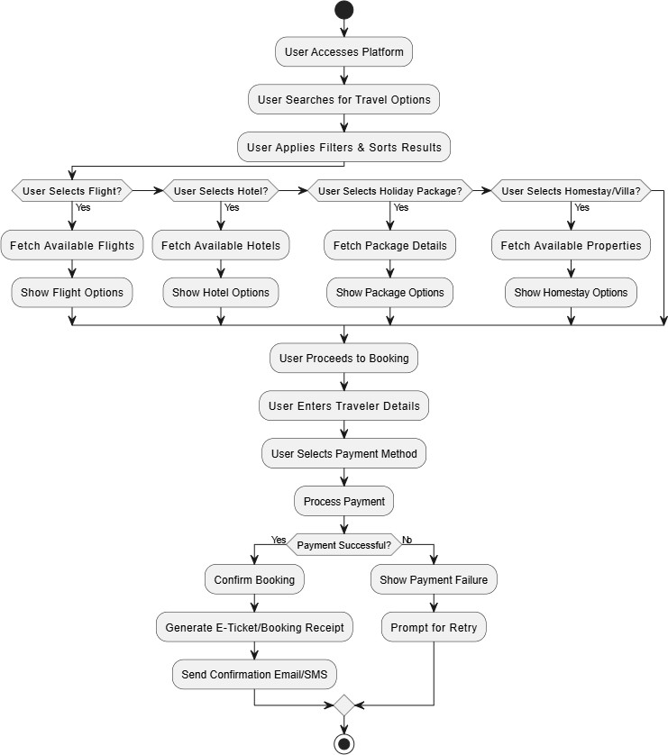
Figure 6 Flow Diagram

4.5 ER Diagram

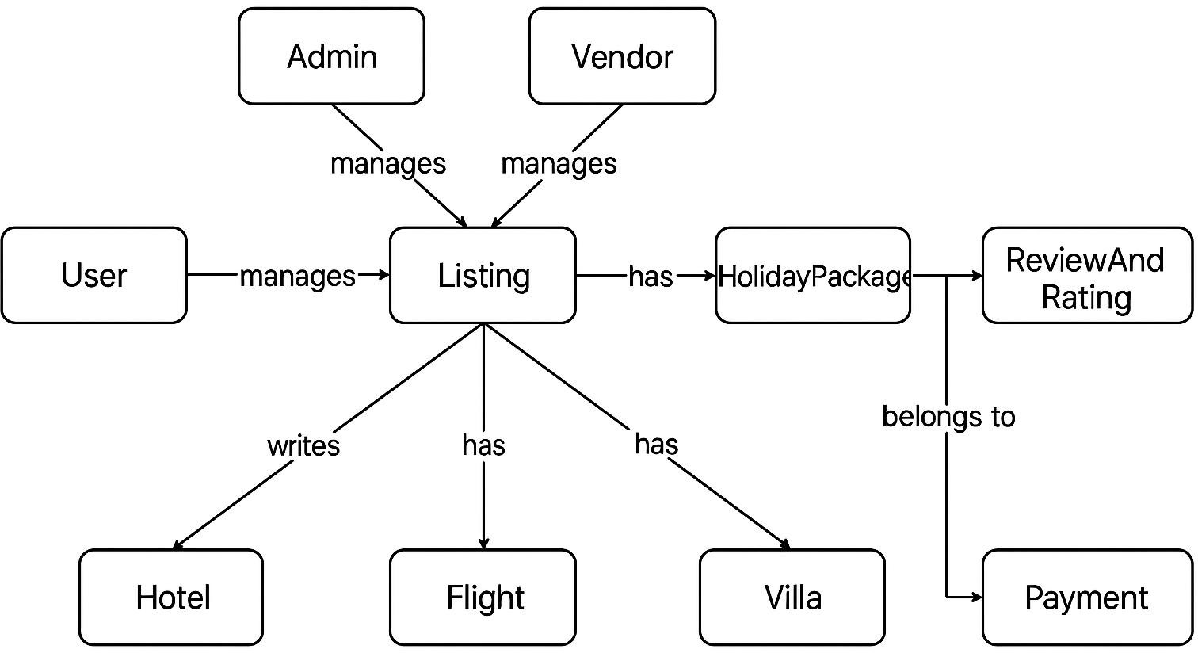

Figure 7 ER Diagram

IMPLEMENTATION PLANNING

Implementation Environment
For implementing the Travel Online Booking App, we require the following platforms, tools, and technologies:

Development Environment
          - Visual Studio Code – Used for writing and managing both front-end (React.js) and back-end (Node.js, Express) code.
          - Node.js & Express.js – Backend framework for handling API requests, authentication, and business logic.
          - React.js – Frontend framework for building the user interface with reusable components.
          - MySQL – Relational database for storing user data, bookings, and travel details.

API Development & Testing
          - Postman – Used to test and debug REST APIs, ensuring proper request and response handling.
          - Swagger – For API documentation and testing endpoints.

Version Control & Deployment
          - Git – Used for source code management, version control, and team collaboration.
          - GitHub/GitLab – Repository for storing and sharing the project code.
          - CI/CD Pipelines (GitHub Actions/Jenkins) – Automating build, test, and deployment processes.

Hosting & Deployment
          - AWS EC2 / Vercel / Netlify – Hosting platforms for deploying frontend and backend services.

Security & Authentication
          - JWT (JSON Web Token) – Secure authentication and authorization.
OAuth 2.0 (Google OAuth) – Used for social login authentication.
          - Twilio API – For sending OTP verification messages to users.

Third-Party Integrations
          - Razorpay / Stripe – For secure online payment processing

Module Specification
- Registration Module – User sign-up with email, phone, OTP verification.
- Login Module – Secure login via email, Google OAuth, or OTP.
- Search & Booking Module – Search and book flights, hotels, holiday packages, homestays & villas with filters and dynamic pricing.
- Payment Module – Secure transactions via Razorpay with refund management.
- User Profile Module – Manage bookings, history, and saved locations.
- Vendor Management Module – Vendors update listings, pricing, and availability.
- Admin Panel – Admins oversee users, vendors, complaints, and analytics.
- Notification Module – Sends email, SMS, push notifications for bookings and offers.
- User Interface Module – React.js & Tailwind CSS ensure a smooth UI/UX.
- Backend Module – Node.js & Express.js handle API requests and authentication.
- Database Module – MySQL stores user, booking, and transaction data.

Coding Standards

Naming Conventions

          - Variables & Functions: Use camelCase (e.g., fetchBookings).
          - Classes & Components: Use PascalCase (e.g., BookingService).
          - Constants: Use UPPER_CASE_SNAKE_CASE (e.g., JWT_SECRET_KEY).
          - Files & Folders: Follow kebab-case (e.g., user-controller.js).
          - Database Tables & Columns: Use snake_case (e.g., user_bookings).

Code Structure & Formatting

          - Maintain a modular structure (separate controllers, models, routes).
          - Use 2-space indentation (JavaScript) or 4-space indentation (Python).
          - Keep brackets on the same line for functions and conditionals.
          - Use Prettier/ESLint for automatic formatting.

Security Best Practices

          - Hash passwords using bcrypt before storing them.
          - Use JWT tokens for authentication.
          - Sanitize inputs to prevent SQL injection & XSS.
          - Restrict API access using role-based authentication.

Error Handling & Logging

          - Implement try-catch blocks for database/API calls.
          - Use proper HTTP status codes (400 for bad request, 500 for server errors).
          - Log errors using Winston or Morgan for debugging.

API Design Guidelines

          - Follow RESTful API principles (GET, POST, PUT, DELETE).
          - Use meaningful routes (e.g., /api/bookings instead of /getdata).
          - Return standardized JSON responses with success & error messages.

Database Query Standards

          - Use ORMs like Sequelize or SQL Alchemy for structured queries.
          - Write parameterized queries to prevent SQL injection.
          - Optimize with indexes, joins, and caching where needed.

Version Control & Deployment

          - Use Git with structured commit messages (e.g., feat: add booking feature).
          - Maintain separate branches (main, dev, feature branches).
          - Deploy using CI/CD pipelines (GitHub Actions, Docker, Kubernetes).

Testing & Debugging

          - Write unit tests using Jest/Mocha for backend & React Testing Library for frontend.
          - Test APIs with Postman before deployment.
          - Enable hot-reloading in development with tools like Nodemon.

TESTING

Testing Plan
The testing technique used in this project is White Box Testing, as it ensures that the internal structure, logic, and code implementation function as expected.

White Box Testing:
- This testing method evaluates the internal code, logic, and structure to verify the correct flow of inputs and outputs.
- It helps improve efficiency, security, and usability by detecting issues at the code level.
- Among the two primary testing methods, Black Box Testing and White Box Testing, this project uses White Box Testing as the internal functionalities are well known.

Key Aspects of White Box Testing:
- Ensures that user authentication, booking processes, and payment transactions are correctly implemented.
- Validates API calls, database queries, and business logic execution.
- Helps detect performance bottlenecks and security vulnerabilities before deployment.

Testing Strategy

The testing process is conducted in multiple phases to ensure system reliability, functionality, and performance. Each phase involves different testing techniques to detect and fix errors early.

Types of Testing:

- Unit Testing: Focuses on testing individual components or functions of the system to verify that they work as expected. It helps in identifying and fixing issues at the code level before integration.
- Integration Testing: Ensures that different modules of the application work together seamlessly. It verifies data flow and interaction between components like the frontend, backend, and database.
- System Testing: Tests the entire system as a whole to ensure that all functional and non- functional requirements are met before deployment.
- Acceptance Testing: Conducted to validate whether the application meets user expectations and business requirements before release.

Additional Testing Methods:

- Smoke Testing: A preliminary check to confirm that the critical functionalities of the application are stable enough for further testing.
- Exploratory Testing: A manual testing approach where testers explore the system dynamically to find unexpected bugs and usability issues.
- Regression Testing: Ensures that new features, updates, or bug fixes do not negatively impact existing functionality. This is crucial for maintaining system stability after code modifications.
- Performance Testing: Evaluates the application's responsiveness, scalability, and speed under different load conditions. It helps in identifying performance bottlenecks.
- Security Testing: Ensures that the application is protected from vulnerabilities such as unauthorized access, data breaches, and cyber threats.

Test Cases

Functionality under test | Test Case | Expected Output | Actual Output | Result
Test  Connectivity | Validate input parameters  (username,  password,email) | Test  Connectivity passed the  message | Test  Connectivity passed the  message | Passed
Create User | Validate input parameters. | The user will be created with a  unique User ID for each user. | The user will be created with a  unique User ID for each user. | Passed
Acknowledge user | Validate input parameters  (email id) | The user will get an  acknowledgment email just after  registering on the platform. | The user will get an  acknowledgment email just after  registering on the platform. | Passed

Search for Hotels | Validate input parameters  (location, check- in/out date,  guests) | The system displays  available hotels matching the  criteria. | The system displays  available hotels matching the  criteria. | Passed
Book a Hotel | Validate input  parameters (hotel selection, guest  details, payment) | The hotel booking is confirmed, and a confirmation  email is sent. | The hotel booking is confirmed, and a confirmation  email is sent. | Passed

Search for Holiday Packages | Validate input parameters  (destination,  duration, budget) | The system lists available holiday packages. | The system lists available  holiday  packages. | Passed
Book a Holiday Package | Validate input parameters  (package selection,  traveler details, payment) | The package is booked  successfully, and a confirmation email is sent. | The package is booked  successfully, and a confirmation email is sent. | Passed
Search for  Homestays & Villas | Validate input parameters  (location, check- in/out date,  guests) | The system shows available homestays and  villas | The system shows available homestays and  villas | Passed
Book a  Homestay or Villa | Validate input parameters  (selection, guest details, payment) | The  homestay/villa is booked  successfully, and a | The  homestay/villa is booked  successfully, and | Passed

 |  | confirmation email is sent. | a confirmation email is sent.
View Booking History | Validate input  parameters (user ID) | The system  displays all past and upcoming bookings. | The system  displays all past and upcoming bookings. | Passed
Payment Processing | Validate input parameters  (payment details, amount) | The system securely  processes the payment and confirms the transaction. | The system securely  processes the payment and confirms the transaction. | Passed
Log out | Validate input parameters  (username) | The user will be able to log out from the platform when needed. | The user will be able to log out from the platform when needed. | Passed

Table 5 Test Cases

USER MANUAL

Home Page

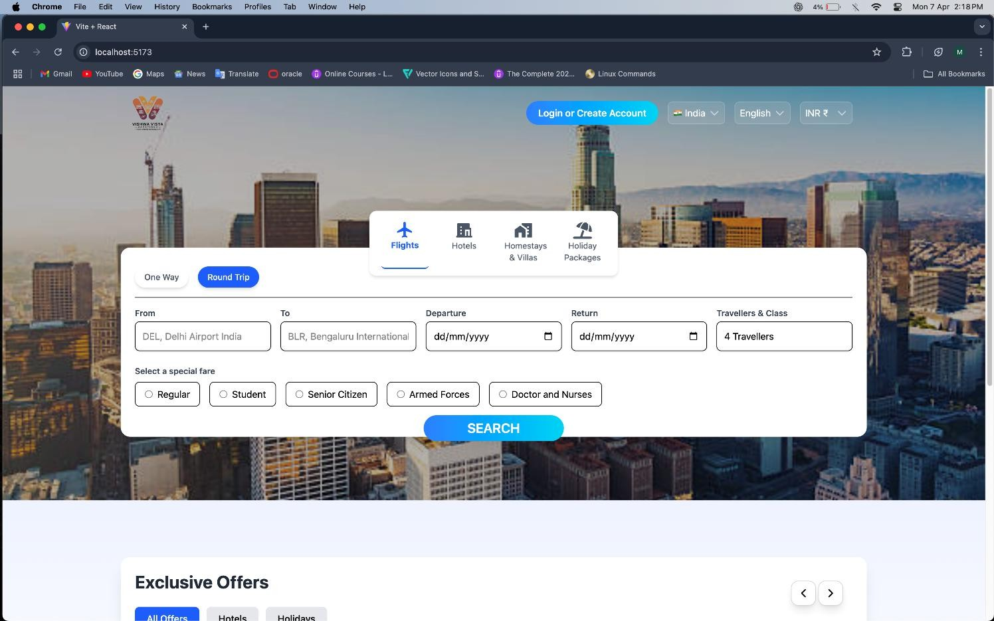

Figure 8 Home

Login
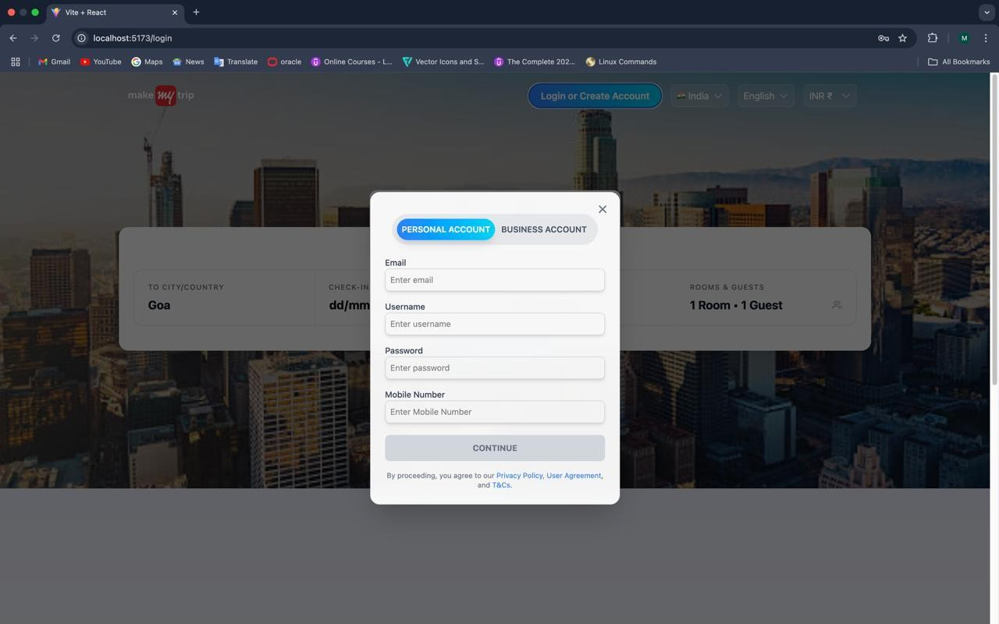
Figure 9 Login

Vendor Business Details
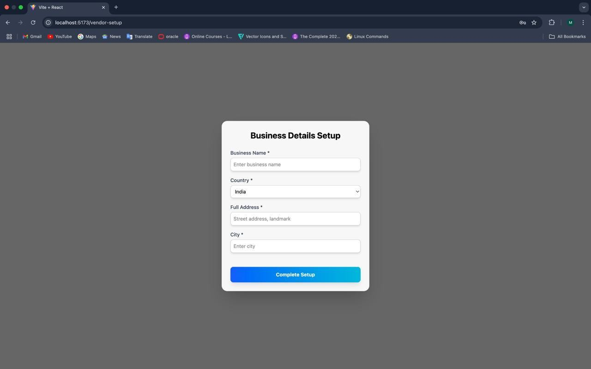
Figure 10 Vendor Business Details

Add hotel
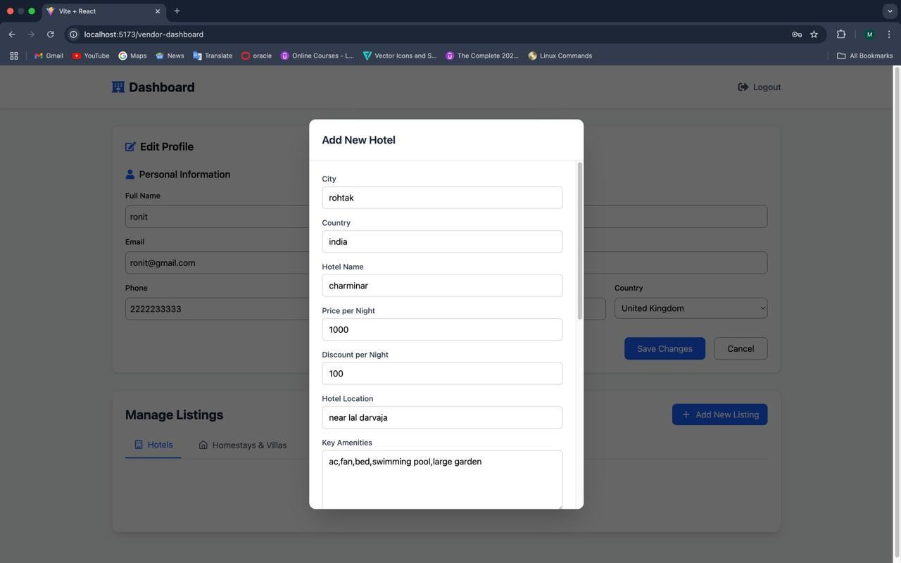
Figure 11 Add Hotel

Dashboard
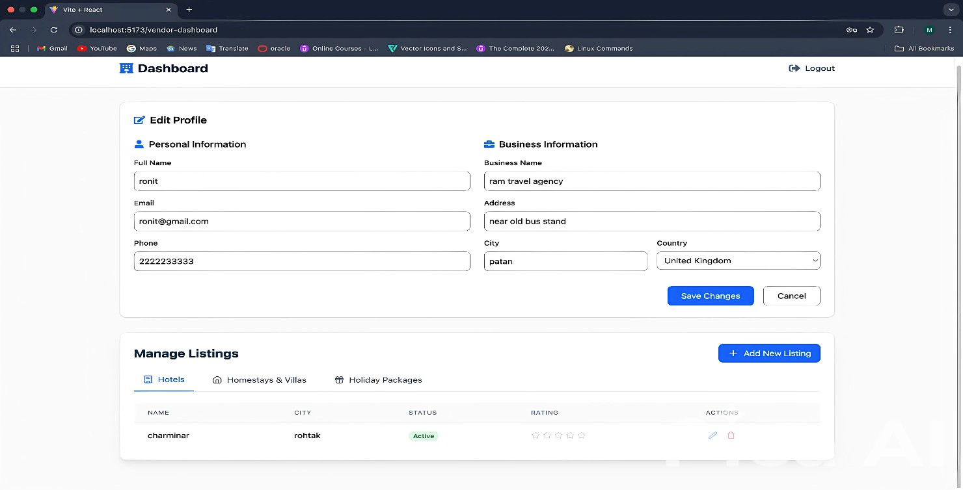
Figure 12 Dashboard

Edit Listing
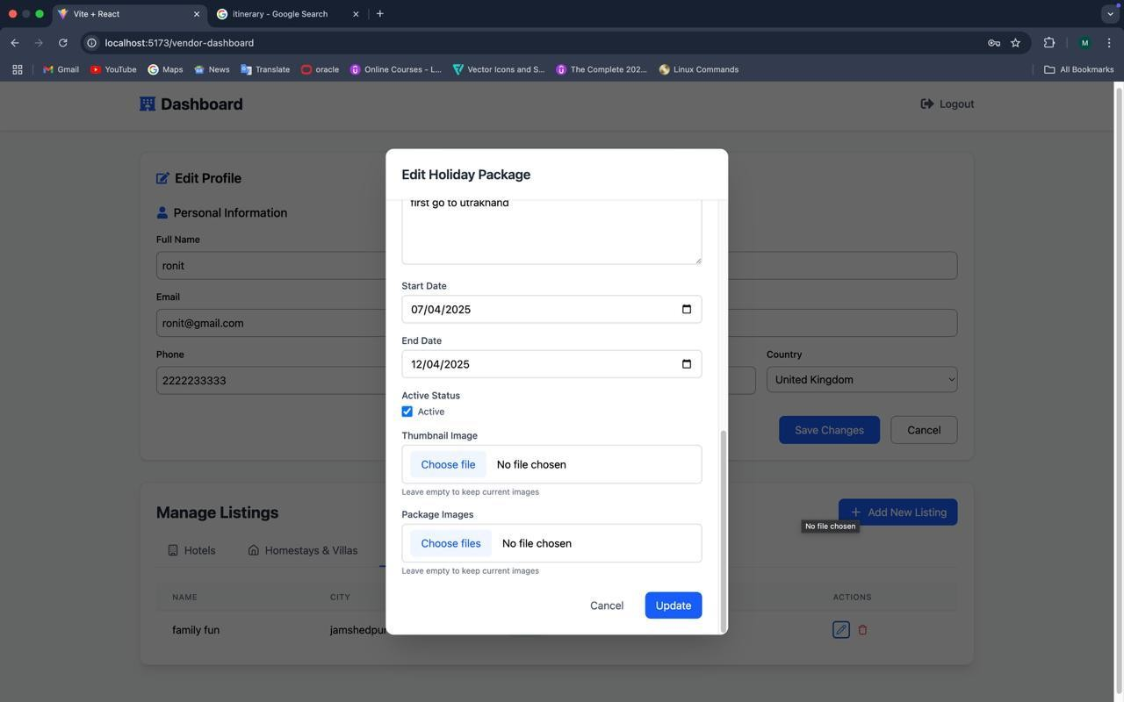
Figure 13 Edit Listing

Listing search
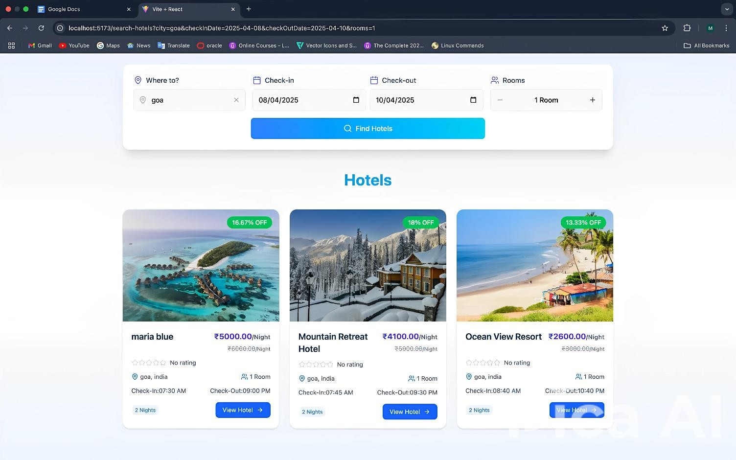
Figure 14 Listing Search

Details of Listing.
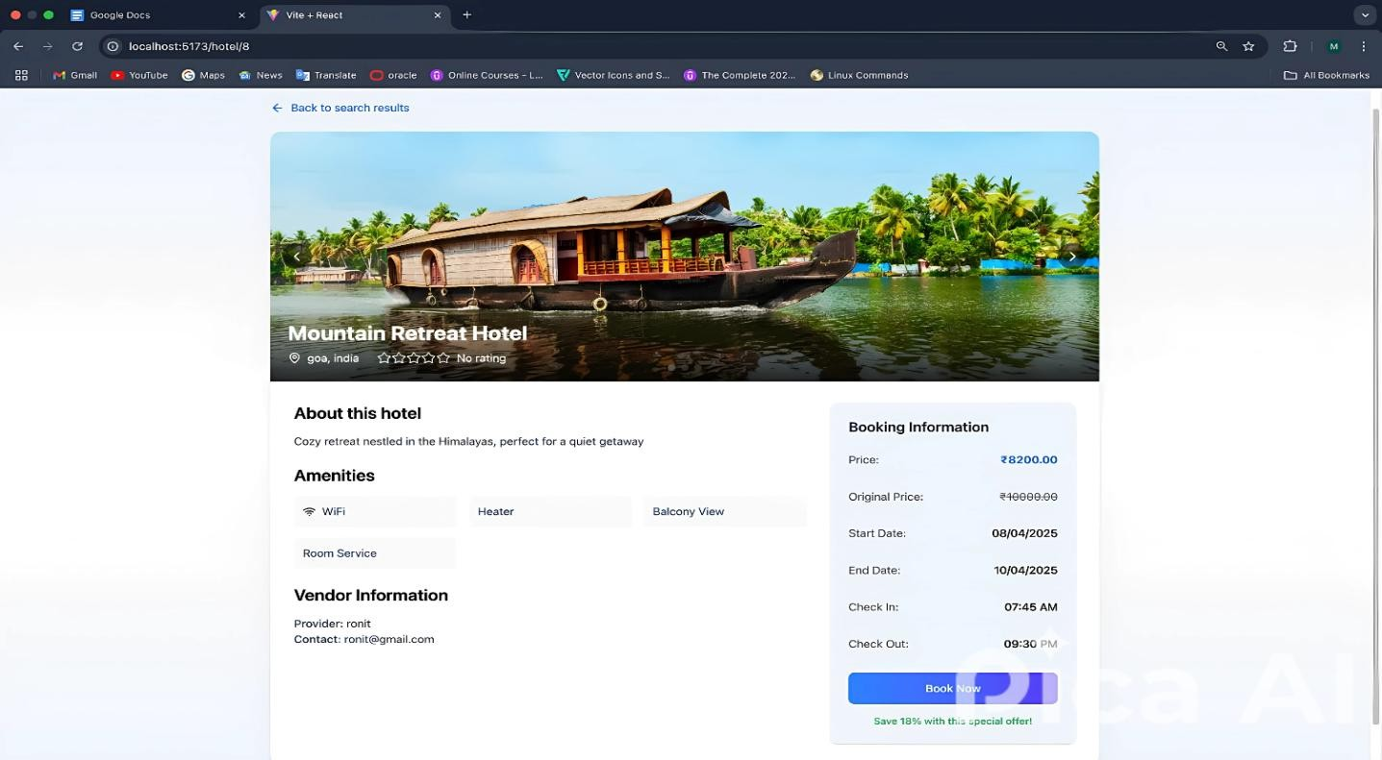
Figure 15 Details of Listing

Payment Gateway
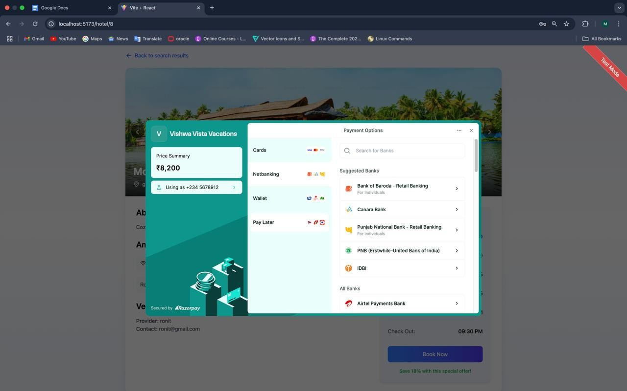
Figure 16 Payment Gateway

Payment Success
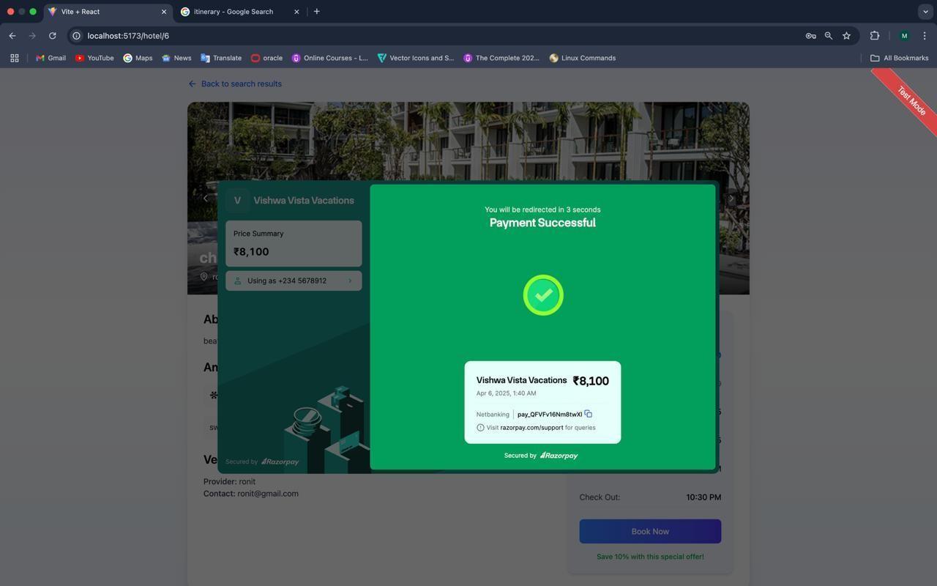
Figure 17 Payment Success

LIMITATION AND FUTURE ENHANCEMENTS

Limitation

- The system depends on third-party APIs for flight, hotel, and payment processing, which may have request limits or occasional downtime, affecting service availability.
- Users can only book one flight, hotel, or holiday package per transaction, limiting bulk bookings for group travel.
- The platform currently does not support real-time price fluctuations or bidding for travel deals, restricting dynamic pricing options.
- Offline booking and modifications are not supported, requiring users to have an internet connection for all transactions.
- The system does not support multi-currency transactions, limiting international travelers who prefer payments in different currencies.
- Refunds and cancellations are subject to the policies of third-party service providers, which may result in delays in processing user requests.
- The app currently does not offer AI-based personalized travel recommendations based on user preferences and history.
- Limited support for local transportation booking (e.g., car rentals, taxis), requiring users to use external platforms for ground travel arrangements.

Future Enhancements

- Flight Enhancements: Introduce real-time flight tracking and notifications for delays, cancellations, and gate changes.
- Group Tour Booking: Allow users to book group tours with shared accommodations, transport, and discounts for bulk reservations.
- AI-Based Recommendations: Implement an AI model to suggest personalized travel plans based on user preferences, past bookings, and budget.
- Multi-Currency Support: Enable payment in multiple currencies with real-time exchange rate conversion for international travelers.
- Dynamic Pricing: Integrate real-time price tracking and bidding for better deals on flights, hotels, and holiday packages.
- Loyalty & Rewards Program: Introduce a reward system where users earn points for bookings and redeem them for discounts on future trips.
- Local Transport Integration: Provide options to book taxis, car rentals, and public transport directly from the app.
- Multi-Document Uploads: Allow users to upload and manage multiple travel documents (e.g., passport, visa, itinerary) in one place.
- Voice-Based Booking Assistant: Enable voice commands to search and book flights, hotels, and packages for a hands-free experience.
- Travel Insurance Integration: Offer travel insurance options directly within the booking process for user convenience

- Social Travel Planning: Allow users to create and share travel itineraries with friends or collaborate on trip planning in groups.

Vision and applications:

Vision
The Travel Online Booking App aims to revolutionize the travel experience by providing a seamless, AI-driven, and user-friendly platform for booking flights, hotels, holiday packages, and homestays. The vision is to integrate intelligent recommendations, real-time updates, and hassle-free booking processes, ensuring convenience and affordability for travelers worldwide.

Applications
- Flight Booking: Users can search, compare, and book flights with real-time price updates and seat selection.
- Hotel Reservations: Provides access to a wide range of hotels with user reviews, ratings, and personalized suggestions.
- Holiday Packages: Offers curated travel experiences, including sightseeing, activities, and guided tours.
- Homestays & Villas: Connects users with local accommodations for a more personalized and affordable stay.
- AI-Powered Travel Recommendations: Suggests destinations, hotels, and activities based on user preferences and past bookings.
- Group Tour Booking: Enables users to plan and book group trips with shared costs and discounts.
- Itinerary Management: Organizes travel plans, including flight details, hotel check-ins, and sightseeing schedules.
- Secure Payment & Multi-Currency Support: Facilitates smooth transactions with various payment options and currency conversions.
- Customer Support & Chatbot Assistance: Provides instant support for queries related to bookings, cancellations, and modifications.
- Loyalty & Rewards System: Encourages user engagement by offering discounts, cashback, and exclusive deals on frequent bookings.

Summary of project work

    - The Travel Online Booking App is a medium to high-level web application designed to simplify the process of booking flights, hotels, holiday packages, homestays, and group tours. The platform provides a seamless experience by integrating AI-driven recommendations, helping users find the best travel options based on their preferences and past behavior.

    - The application follows a modular architecture with various components such as user authentication, real-time search, booking management, secure payments, and itinerary

tracking. Users can register, log in, and manage their bookings efficiently. The secure payment system ensures safe transactions, and the platform supports multiple currencies for international users. A built-in chat support system enhances customer assistance, while a loyalty rewards feature encourages user retention.

    - For the backend, the system is developed using Node.js and MySQL, ensuring scalability and performance. The frontend is built with React.js, providing a responsive and user-friendly interface. The implementation follows strict coding standards and white-box testing strategies to maintain quality and reliability.

    - Looking ahead, the project aims to incorporate AI-powered itinerary suggestions, enhance image-to-text and text-to-image functionalities, and support multi-document uploads for users looking to analyse multiple travel plans. Future improvements will also focus on expanding the chatbot’s capabilities, optimizing search performance, and improving personalization features.

CONCLUSION

- The Travel Online Booking App is designed to simplify the process of booking various travel-related services such as flights, hotels, holiday packages, homestays, and group tours while offering a seamless and personalized experience to users. The application integrates secure authentication, smooth payment processing, and real-time booking updates to enhance the user journey. The system ensures high efficiency by leveraging a modular structure, where each module plays a crucial role in providing a streamlined experience.

- One of the key highlights of the project is the implementation of AI-powered recommendations. By analyzing user preferences, search history, and past bookings, the system can suggest the best travel options tailored to individual needs. This AI-driven approach enhances customer satisfaction and increases engagement by offering personalized travel experiences. Additionally, features like query processing, document upload for itinerary management, voice interactions, and email notifications make the platform more user-friendly and efficient.

- From a technical perspective, the project is built using a React.js frontend for a responsive and interactive user interface, while the backend is powered by Node.js and MySQL to handle data management, authentication, and secure transactions. The integration of APIs allows users to fetch real-time information about flight schedules, hotel availability, and pricing. The system ensures robust performance and security, adhering to coding best practices and following standardized development methodologies.
- To maintain quality and reliability, the project follows a white-box testing strategy, allowing developers to test internal structures, logic flows, and functionalities. The unit, integration, smoke, exploratory, and regression testing techniques ensure that the application remains stable, bug-free, and optimized for performance. Security measures, including data encryption, secure authentication mechanisms, and error handling, have been implemented to safeguard user information.
- Despite its strong capabilities, the application does have some limitations. Currently, it only supports PDF uploads, limiting users from managing itineraries through other document formats. The chatbot functionality, though efficient, does not support image-based interactions such as image-to-text or text-to-image conversion. Additionally, the current implementation relies on API keys, which may impose restrictions on the number of queries served, potentially affecting scalability.
- Looking ahead, future enhancements will focus on expanding AI capabilities, supporting multiple document formats, and integrating additional services. Features like multi- document analysis, real-time AI-based travel itinerary suggestions, and chatbot enhancements for better query handling will further improve the platform’s usability. Additionally, enhancing group tour bookings, expanding the range of supported travel

CONCLUSION
- services, and optimizing backend performance will contribute to making the system more powerful and scalable.
- In conclusion, the Travel Online Booking App is a well-structured, efficient, and scalable solution for modern travelers. By integrating AI-driven recommendations, a user-friendly interface, and a secure backend, the platform aims to provide a seamless and hassle-free travel booking experience. Continuous improvements and feature expansions will further solidify its position as a comprehensive travel solution catering to a wide range of users and their diverse travel needs.

REFERENCES
- React, "React – A JavaScript library for building user interfaces," [Online]. Available: https://react.dev/. [Accessed: 06-Feb-2025].

- Node.js, "Introduction to Node.js," [Online]. Available: https://nodejs.org/en/learn/gettingstarted/. [Accessed: 20-Feb -2025].

- MongoDB, "MongoDB Documentation," [Online]. Available: https://www.mongodb.com/docs/. [Accessed: 08-Feb -2025].

- Google Developers, "Get started with optimizing your React app," [Online]. Available: https://web.dev/articles/get-started-optimize-react. [Accessed: 10- Feb-2025].

- MySQL, "MySQL Documentation," [Online]. Available: https://dev.mysql.com/doc/. [Accessed: 10-Feb-2025].

- OWASP, "OWASP Top Ten – Secure Authentication and Authorization Practices," [Online]. Available: https://owasp.org/www-project-top-ten/. [Accessed: 3-Mar-2025].

- Statista, "Online Travel Market - Statistics & Facts," [Online]. Available: https://www.statista.com/topics/962/online-travel-market/. [Accessed: 08-Mar -2025].

- Cloudinary, "Cloudinary Documentation – Image and Video Management," [Online]. Available: https://cloudinary.com/documentation. [Accessed: 15- Mar -2025].

- Cloudinary, "Secure Image and Video Uploading – Upload Options," [Online]. Available: https://cloudinary.com/documentation/upload_images#upload_options. [Accessed: 15-Mar- 2025].

EXPERIENCE
Working on the Travel Online Booking App was a challenging yet rewarding experience that enhanced my technical expertise and problem-solving skills. Throughout the development process, I worked on various aspects of the project, including frontend, backend, database management, API integration, and deployment.

Technical Experience:

- Frontend Development: Built an interactive user interface using React.js and Tailwind CSS, ensuring a responsive and intuitive booking experience.

- Backend Development: Developed a Node.js and Express.js backend with secure authentication using JWT, and Twilio OTP verification.

- Database Management: Designed and optimized the MySQL database schema, ensuring efficient handling of user bookings, payments, and travel-related data.

- API Development & Integration: Created and tested RESTful APIs using Postman, integrating third-party services for flight, hotel, and tour package searches.

- Real-time Features: Implemented Socket.IO for real-time chat functionality, enabling instant customer support and communication.

- Cloudinary Integration: Used Cloudinary for storing and managing images and media files, ensuring optimized storage and fast loading times.

- Handling complex authentication flows: (OAuth, OTP, JWT) helped me understand security best practices.

- Optimizing database queries: improved my knowledge of SQL indexing and performance tuning.

- Debugging API issues: while integrating flight and hotel services enhanced my API handling and troubleshooting skills.

Overall Experience
This project significantly improved my full-stack development skills, from designing user- friendly interfaces to managing databases and deploying applications. It also strengthened my ability to solve real-world challenges and build scalable, efficient solutions.

